 | MODE SETTINGS
 | 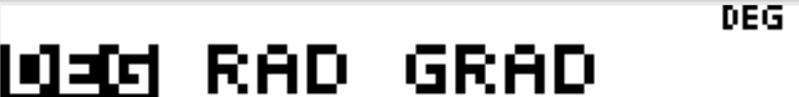 |  | For middle school, we ususally do not change the Geometry mode, just use the default DEG (you will always see this setting at the top of the screen)  How the output appears can be controlled by the NORM or SCI settings (output can be in scientific notation)  FLOAT is for decimal placement. Or, you can choose how many decimal places your want your answer given.  MATHPRINT will give answers in exact format (stacked fractions or radical)  CLASSIC will give rounded answers as output.
 | BASIC FUNCTIONS OF TI-30XS MULTIVIEW
 | SPECIAL FUNCTION BUTTONS  - When to use $\frac{n}{d}$ vs. ÷  - Exact or Approximating? (Remember, there is a toggle button )  - Using $\frac{n}{d}$$U\frac{n}{d}$  - Copy & Paste  - Storing values  - sto  - Exponents, using x² or ^ (carrot key)  - Radicals, using square root or n^{th} root  - Scientific Notation |  | Examples:  Add $\frac{1}{2}+\frac{1}{3}$ or Add $\frac{1}{4}+\frac{1}{7}$  Convert $4\frac{1}{5}$ to an improper fraction  Change the last entry to $4\frac{2}{5}$  For a circle: Given C = 124 in.  Find the area, to the nearest hundredths.  Evaluate (5)² – 8(3)  Evaluate (-3)⁴ + 14  Evaluate $\sqrt{8}$  Evaluate $\sqrt[4]{81}$  Convert 2.345 x 10⁻³ to standard numerical value
 | RESET TO DEFAULT SETTINGS
Remind students that they should start each problem by clearing their calculator. | Shortcut: and at the same time  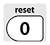  OR :  Students will see: on their screen  This is also something I have them do before each test; I must see the message before I hand them their test.
 | NUMBERS & OPERATIONS
PA.N.1.2 Express and compare approximations of very large and very small numbers using scientific notation. | CONVERTING BETWEEN STANDARD NUMBERS AND SCIENTIFIC NOTATION  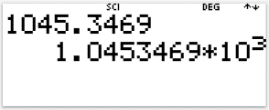  Write 1045.3469 in Scientific Notation  Change MODE settings to SCI  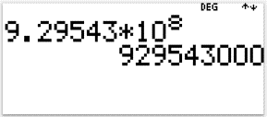  Write 9.29543 X 10⁸ as a standard number.  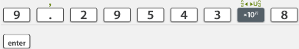  (Need to reset MODE)
PA.N.1.3 Multiply and divide numbers expressed in scientific notation and express the answer in scientific notation. | MULTIPLY AND DIVIDE WITH SCIENTIFIC NOTATION  Multiply: $(1.257×{10}^{3})(9.2333×{10}^{-4})$  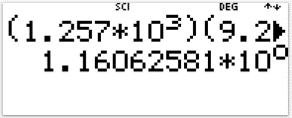  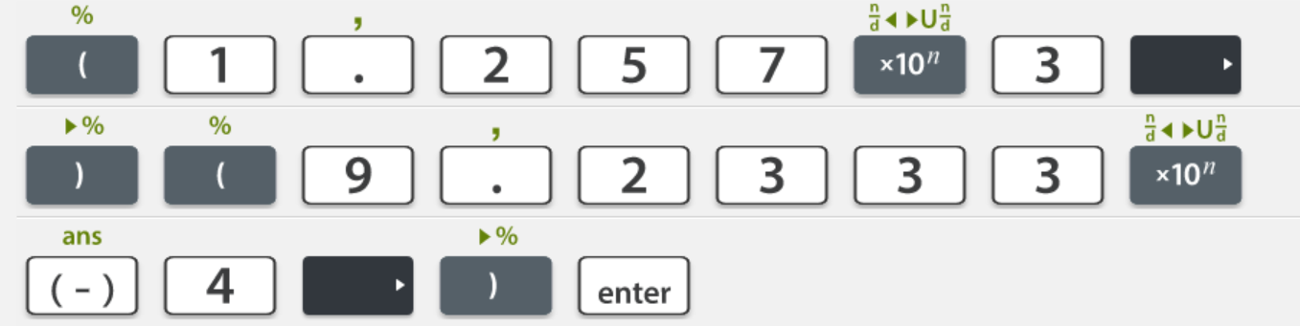  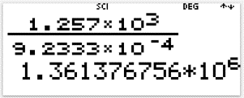  Divide: $\frac{(1.257×{10}^{3})}{(9.2333×{10}^{-4})}$  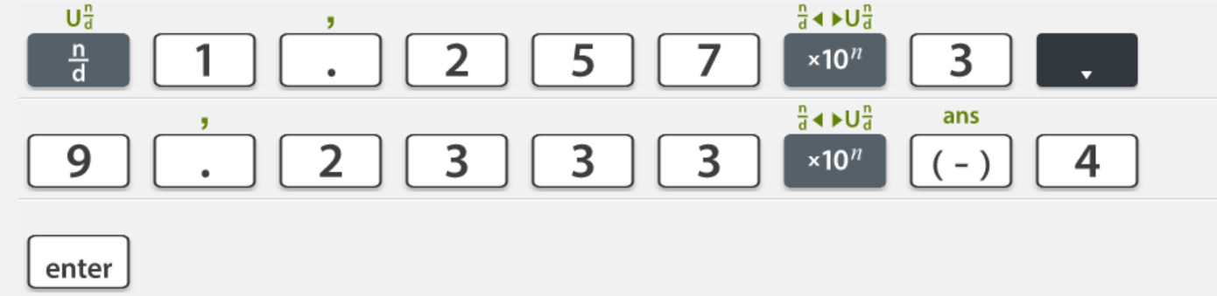
PA.N.1.4 Compare and order real numbers; locate real numbers on a number line. Identify the square roots of perfect squares to 400 or, if it is not a perfect square root, locate it as an irrational number between two consecutive positive integers. | ACTIVITY PART A  Have students complete a chart of perfect squares from 1-20. Allowing them to use the calculator will shorten the activity time and allow students to make several discoveries/connections with many commonly used perfect square numbers like 9, 25 and 100.  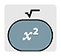  And continue to complete 1 to 20.  ACTIVITY PART B  Have students complete a chart for square roots of the numbers 1-20. The TI-30 Multiview will reduce radicals, when possible, but this builds an understanding between perfect and not-perfect squares.  .  .  .  Use this opportunity to look at the right side of the screen. Students can scroll up and down to help in a great conversation about non-perfect square values between two integer perfect square roots.
The next activity is a continuation from the previous. It is the extension of your discussion of non-perfect square roots, using the TOGGLE BUTTON
to convert non-perfect square values to decimal numbers.
This should lead to the discussion of approximation. Teach students to round to 3 decimal places, unless directions state otherwise. This is ACT Standards.
ACTIVITY PART A
Now that students have a list of perfect and non-perfect square numbers, focus on the non-perfect square numbers. By using the
Toggle Button, students will see the decimal value of each non-perfect square number and clearly establish that it is between two consecutive integer numbers. The calculator shows that each of these decimal numbers are non-repeating/non-truncating numbers, therefore they belong to the IRRATIONAL SET of numbers in the Real Number System.
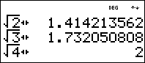

Have students to continue the activity and fill in a new chart of approximate values of square root for the numbers 1-20, or maybe even higher…

 |  | MEASURES OF CENTRAL TENDENCY
PA.D.1.1 Describe the impact that inserting or deleting a data point has on the mean and the median of a data set. Create data displays using technology to examine this impact. |  | ACTIVITY PART A  1-Variable Stats can be a lot of fun with students  There are several ways you can collect data in your classroom, some of my favorites are: What day of the month were you born, Measure of your shoe length and How big headed are you. These activities give you a chance to be included in the data and you can use your own data as one that insert or delete at any time.  (If you want to create shorter lists, split class into groups of 3 or 4 and have the group produce an average measure for their group.)  Analyze data quickly with the calculator. This gives you an opportunity to teach special notation they will see more frequently as they move into high school.  For this example, I will use the data set {6, 6.5, 6.75, 7, 7, 7.5, 8, 8, 8, 9}  HAVE STUDENTS DO THE RESET – MEMORY CLEAR, BEFORE STARTING DTA ANALYSIS  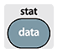  Use the DATA feature and enter all the data values in L1  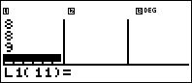  It is important that the students pay attention to the number of entries in their list and that the calculator agrees. This picture shows the curser is in the 11th spot, so 10 entries have been listed.  Students can find the following, using 1-variable Stat: Mean, Median, Min, Q1, Q3, and Max. Students can use the difference in Min and Max to find Range, but will rely on analyzing the frequency of the data for Mode.  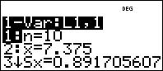  n the number of entries in the list  $\overline{x}$ (X bar) MEAN: The sum of the data values divided by the n[scroll down]  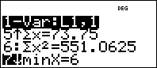  Σx (Σ is the summation symbol) The sum of all the data [Therefore: $\overline{x}$ = $\frac{Σx}{n}$]  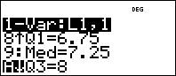  After the calculator analyzes the data in ascending order, sorted least to greatest:  minX Minimum: The smallest data value  Q1 First quartile  (Median of data left of actual median)  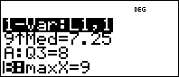  Med Median: ACTUAL MEDIAN, The physical center of the data  (If n is an even number, median is the mean of the two data points on each side of center)  Q3 Third quartile  (Median of data, greater than actual median)  maxX Maximum: The largest data value  Range (maxX – minX) The difference between the min & max  Mode The value that repeats the most (this cannot be found on the calculator)  If you want to add or delete data, you can press the data button at any time to view/edit the list. When you add, or delete data, you will need to repeat the 1-variable Stat steps to view the new analytical information. This is a great way for students to view how changing data effects the mean and median.  ACTIVITY PART B  Box Plots (Box-and-Whisker Plots) represent the 5-number summary of a data list.  5-Number Summary: minX, Q1, med, Q3 and maxX  Form our list: minx=6 Q1=6.75 med=7.25 Q3=8 maxX=9  But how would the boxplot change if the data were changed?  Press the DATA button, again. Scroll down and change the second 7 to 7.5, change the 9 to 8.5. Can you predict what changes and what stays the same, before doing the analysis?
PA.D.1.2 Explain how outliers affect measures of center and spread. |  | To determine if data contains either lower or upper outliers, a quick calculation is needed.  - Find IQR (Inner Quartile Range: Q3 – Q1 = IQR)  - Find your margin for outlier bounds: Margin =n (1.5)(IQR)  - Find lower bounds (LB) applicable to data: LB = Q1 – (1.5)(IQR)  - If there is a data value less than LB, then it is a lower outlier.  - Find upper bounds (UB) applicable to data: UB = Q3 + (1.5)(IQR)  - If there is a data value greater than UB, then it is an upper outlier.  - If all data is between LB and UB, there is no outlier  Let’s check our data:  IQR = 8-6.75 = 1.25 Margin = (1.5)(1.25) = 1.875  LB = 6.75 – 1.875 = 4.875  Since our minX = 6 and is not less than 4.875, we do not have a lower outlier  UB = 8 + 1.875 = 9.875  Since our maxX = 9 and is not greater than 9.875,  we do not have an upper outlier
PA.D.1.1 Describe the impact that inserting or deleting a data point has on the mean and the median of a data set. Create data displays using technology to examine this impact.  (Revisited)  Using Frequency Tables with  1-Variable Data |  | 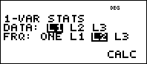  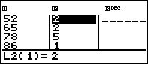  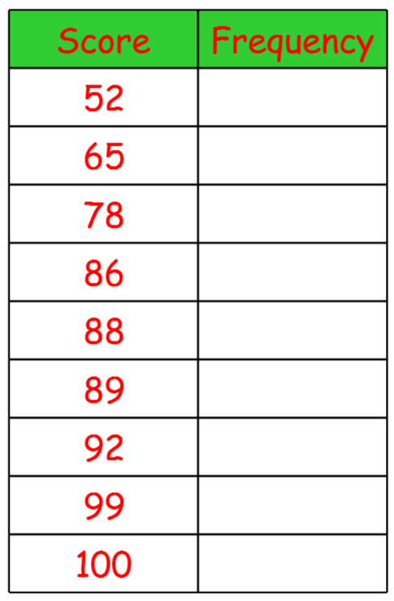  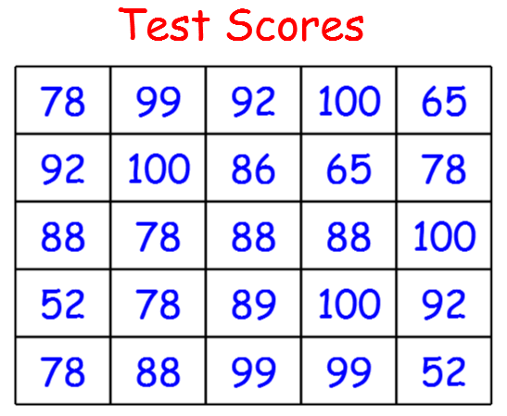
 |  | PROBABILITIES
PA.D.2.1 Calculate experimental probabilities and represent them as percents, fractions, and decimals between 0 and 1. Use experimental probabilities to predict relative frequencies when actual probabilities are unknown.  PA.D.2.2 Determine how samples are chosen (randomness) to draw and support conclusions about generalizing a sample to a population, including identifying limitations and biases.  PA.D.2.3 Define, compare, and contrast the probabilities of dependent and independent events |  | ACTIVITY PART A  PROBABILITY – How likely something is to happen.  P(E) = $\frac{\text{the number of elements that you are looking for}}{\text{the number of total number in your sample set}}= \frac{\text{The Number Of Desired Events (E)}}{\text{The Total Number Of Possible Outcomes (N)}}$  The probability of an event is written as a simplified ratio (fraction) or its decimal representation.  When the probability is referred to as chance, then the answer is converted to a percent.  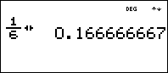  Rolling one number cube: $P\left(6\right)=\frac{1}{6}$  converted to a decimal  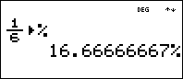  or converted to percent  ACTIVITY PART B  OUTCOMES - When the number of possible outcomes is calculated from a group, then you must consider if the order of the groups elements presented will matter.  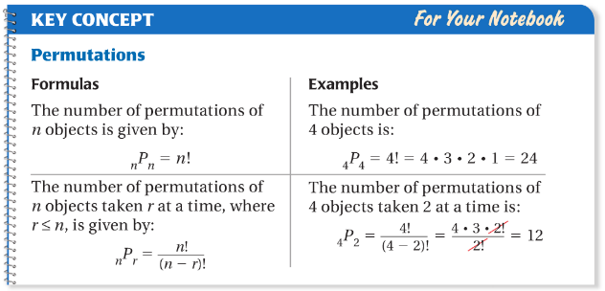  If you are picky about the order, then you need to calculate the number of possible outcomes using PERMUTATIONS.  EXAMPLE: What if there were 5 officers for our Multicultural Club and we needed to pick a President and Vice President?  ON PAPER: ₅P₂ = $\frac{5!}{\left(5-2\right)!}=\frac{5∙4∙3∙2∙1}{3∙2∙1}=5∙4=20$  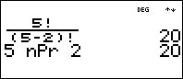  ON TI-30XS (USING FACTORIAL): $\frac{5!}{\left(5-2\right)!}$  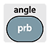  ON TI-30XS (USING NOTATION): ₅P₂  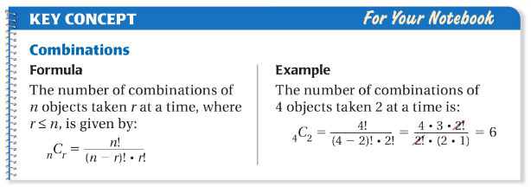  If the order doesn’t matter, then you can eliminate duplicate subsets, which produces a smaller number of possible outcomes. Use  COMBINATIONS  What if you were asked to send 2 of your 5 officers to the office, to pick up paperwork you needed? It not important which 2 go get the paperwork.  ON PAPER: ₅C₂ = $\frac{5!}{\left(5-2\right)!∙2!}=\frac{5∙4∙3∙2∙1}{(3∙2∙1)(2∙1)}=5∙2=10$  ON TI-30XS (USING FACTORIAL):  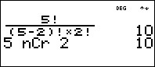  ON TI-30XS (USING NOTATION):
 |  | EXPRESSIONS
PA.A.3.1 Use substitution to simplify and evaluate algebraic expressions.  PA.A.3.2 Justify steps in generating equivalent expressions by combining like terms and using order of operations (to include grouping symbols). Identify the properties used, including the properties of operations (associative, commutative, and distributive). |  | ACTIVITY PART A  The use of the calculator can help students understand order of operations, as it applies to variable substitutions. Where students must their steps on paper, they can enter their steps to verify if their simplified expression is equivalent to the first.  Example: 5-2x when x = -3,  Student Work On Paper: Calculator shows:  5 – 2(-3)  3(-3)  So, this verifies their first simplifying step of 5 – 3, is not the correct first step.  Example: 5(x – 2)² when x = 4  Student Work On Paper: Calculator shows:  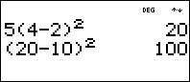  5(4 – 2)²  (20 – 10)²  Before the student continues, finishing with a wrong answer, the calculator shows their distributive property step does not produce equivalent results. They can go back and try again.  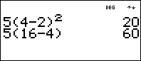  5(4 – 2)²  5(16 – 4)  The calculator shows that using the exponents first is not the correct first step.  Both attempts validate the operation of (4 – 2) should be simplified first. This reinforces the concept of order of operations.  ACTIVITY PART B  This same idea can be used to verify properties with variables.  Start by storing a random number for x, not 1 or 2.  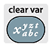 (Stores the number 4 for x)  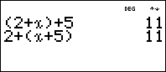  Try (2 + x) + 5 = 2 + (x + 5)  Enter the left expression,  Then enter the right expression  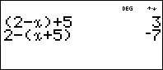  Try (2 - x) + 5 = 2 - (x + 5)  Students can verify that some properties do not hold true for all operations.
 |  | EQUATIONS AND INEQUALITIES
PA.A.4.1 Solve mathematical problems using linear equations with one variable where there could be one, infinitely many, or no solutions. Represent situations using linear equations and interpret solutions in the original context.  PA.A.4.2 Represent, write, solve, and graph problems leading to linear inequalities with one variable in the form $px+q>r$ and $px+q<r$, where p, q, and r are rational numbers. PA.A.4.3 Represent real-world situations using equations and inequalities involving one variable. |  | ACTIVITY PART A  Storing solution value for a variable can be useful in developing proper equation solving strategies.  Solve $2+\frac{1}{2}x=-9$, prove the solution is x = -22  Start by storing a given solution for x, the calculator can produce numerical outputs. If equivalent expressions are entered using the varible, then the calculator should show equivalent output values.  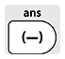 (Stores the number -22 for x)  Enter the left expression  On paper, students should show subtracting 2 on both sides of the equation, then  Enter the new, left expression  Enter the new, right expression  After each equation solving step, repeat the comparisson.  **Be aware that students may use the negative sign and the subtraction button, incorrectly.  This can be used for inequalities, just comparing the output to be greater than or less than the given value. BUT, there is another way
 |  | LINEAR FUNCTIONS AND EQUATIONS
PA.A.1.3 Identify a function as linear if it can be expressed in the form y=mx + b or if its graph is a straight line.  PA.A.2.5 Solve problems involving linear functions and interpret results in the original context.  PA.A.1.2 Use linear functions to represent and explain real-world and mathematical situations.  PA.A.2.1 Represent linear functions with tables, verbal descriptions, symbols, and graphs; translate from one representation to another. |  | ACTIVITY PART A  The table feature allows students to view an equation by it’s table of values.  For SLOPE-INTERCEPT EQUATIONS (It will take other functions):  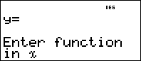  - Students can see patterns in the table and relate the pattern to the coefficient of the x variable, and they should notice that when x = 0, the y value represents the constant value of the equation.  - Try: $y=3x+5$  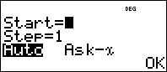  - Start = (Enter the first x value you want to see in the table) PRESS ENTER  - Step = (Enter the scale you want x values to be counted by: Step =1 gives 0, 1, 2, 3 or Step = .5 gives 0, .5, 1, 1.5)  - Auto (Automatically fills in both x and y columns)  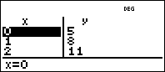  - OK (Takes you to the function table)  - Students can scroll up and down the x column and observe the output y values. It is possible to scroll up, past the chosen x starting value.  - For this example, students should see, as x increases by 1, y increases by 3 (3 is the coefficient for the x variable – the slope of the equation)  - Try finding the x-intercept (scroll to find x, when y = 0)  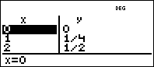  - Try $y=\frac{1}{4}x$  It is clear that as x increases by 1, the y values increase by ¼  - How about using a table to graph a function?  - Try $y=\frac{7}{3}x-\frac{4}{3}$  - Set x to start at 0, step by 1, then look for “Lattice Points”  ACTIVITY PART B  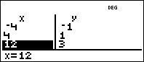  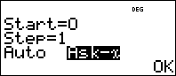  Students can use the Ask-x feature, for Domain & Range questions. When using Ask-x, instead of AUTO, a blank table is produced. Students enter the x values of their Domain and the table will produce the corresponding Range output values.  (The x values can be entered in any order)  Find the Range for $y=\frac{1}{4}x$ and the given D{-4, 4, 8, 12}  Using the Ask-x feature, enter each value of the domain, in the x column, then press enater. The cooresponding output is evealed in the y column.  (Be careful, the Ask-x list only hold 3 x values, when more than three are used the curser stays in the third position and continues to replace the value in that position. The Output y value changes accordingly)
 |  | SCATTERPLOTS
PA.D.1.3 Collect, display and interpret data using scatterplots. Use the shape of the scatterplot to informally estimate a line of best fit. Use appropriate titles, labels and units. |  | ACTIVITY PART A  You are starting with lists of data, not an equation, so you start with pressing the DATA button. (Remind students to perform Memory Clear, first)  Enter x values in L₁, and enter y values in L₂  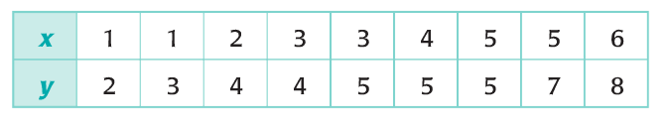  Make sure both columns have the same number of enteries.  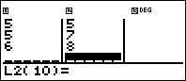  We are calculating a Linear Regression using  2-Variable Stats  - Press  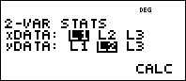  - Pres ENTER three times, to accept the default settings if Memory Clear was performed.  - xData is in L₁  - yData is in L₂  - And we want to calculate the regression  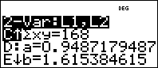  - The calculator produces the equation y = ax + b  - Scroll down to find D: a =___ & E: b=_____  - a = approximated slope value,  - b = approximated y-intercept value  For our data, the Best Fit Equations is: y = 0.949x + 1.615  (Round to 3 decimal places)  The populated values for a and b are stored in their variable key.  Clear the screen and press the variable button five times for a, then press enter.  Press the variable button six times for b, then press enter.  When using the variable button, if you press to many times, keep pressing and the variables will repeat.  Think about how students can use this regression to find slope between two point!  ACTIVITY PART B  The regression information also contains the opportunity to predict x or y values, given a specific input or output value.  - Continue scrolling down to find: G: x’ and H: y’  - x’ is requesting a y-output for a given input  - y’ is requesting the x-input value that produced the given output  Be aware that the requested values are automatically entered into the lists, but not the given values. And, it changes the regression values. You can go back to the data table and delete the last entry, do the regression, then use H: y’
 |  | SOMETHING EXTRA
 |  | QUADRATICS
A1.A.3.3 Factor common monomial factors from polynomial expressions and factor quadratic expressions with a leading coefficient of 1. |  | Imagine teaching factoring of quadratics, using tables...  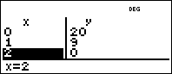  - Try $y=x^{2}-12x+20$  - How about using a table to find roots?  - Use to enter the function  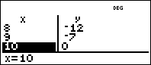  - Set x to start at 0, step by 1, then look for “x-intercepts”  - Ask students how the values are used to create the equation???  Once students recognize that the factors of the constant must have a sum equal to the coeeficient of the 1st degree term, then you can start using the function feature to find pairs of factors.  - Let $x$ represent the first factor of C (the constant value)  - You find the second factor by dividing out the first factor  - So, let $y= \frac{c}{x}$  - Use to enter the function $y= \frac{c}{x}$  - Set x to start at 1 (can’t divide by zero)  - Step needs to be 1 (we need interger values)  - Look for the pair: $x+y=B$  - For our original equation C= 20, but B= -12  - The first picture shows what the table looks like. If students scroll down, they should notice that as x increases, y decreases.  - Have them scroll up  - The first thing they should notice is the error output when x = 0  - Then they will notice both factors are negative.  - This leads to a great review of integer understanding  - How can factors of a positive value have a negative sum  - How can factors of a negitive value have a negative sum  - How can factors of a negative value have a positive sum  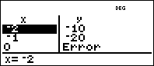  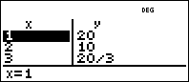  - After they find the correct pair, have them use the table feature and enter the functin as a product of binomials.  - Compare the table of values with the original table  - Do they recognize that the factors are the zeros?

NOTES:
____________________________________________________________________________________________________________________________________________________________________________________________________________________________________________________________________________________________________________________________________________________________________________________________________________________________________________________________________________________________________________________________________________________________________________________________________________________________________________________________________________________________________________________________________________________________________________________

